Lab 9. Preparation of mixed metal EDTA complex MgCu[EDTA].6H₂O
Introduction
EDTA is a hexadentate ligand. It forms complexes with many aqueous metal ions. Four oxygen atoms and two nitrogen atoms bond to the metal in an octahedral arrangement. Ligands such as EDTA that contain many donor atoms are often called chelates. Many examples of mixed-metal EDTA complexes are known and in this experiment you will prepare MgCu[EDTA].6H₂O

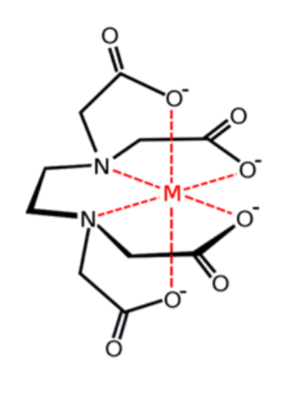
Experimental Procedure
Preparation of MgCu[EDTA].6H₂O
1. Weigh out 0.73 g (2.5 mmol) of ethylenediaminetetraacetic acid, EDTA, into a 125 mL beaker. Add 40 mL (graduated cylinder) of deionized water to the beaker.
2. Weigh out 0.20 g (2.5 mmol) of copper(II) hydroxide and add it to the beaker. Heat the mixture to 50 °C.
3. Weigh out 0.23 g (slightly more than 2.5 mmol) of magnesium carbonate. Add the magnesium carbonate to the beaker in small portions, heating the mixture to 60 °C, stirring vigorously.
4. After about 20 minutes at 60 °C, let any remaining solid settle out and then pour off the solution into an evaporating dish.
5. Evaporate the filtrate slowly over a hot water bath at about 70-80 °C until a syrup remains.
6. Allow the concentrated solution to cool. Scratch the inside of the dish with a glass rod until crystals form.
7. Filter off the crystals and put the filter paper and crystals on a watch glass and dab dry with another piece of filter paper. Cover the crystals with a piece of clean filter paper and leave them to dry at room temperature.
8. Label a sample vial with the name of the product and your name. Weigh the empty labelled vial and record its mass.
9. Transfer the product to the vial, reweigh the vial, and record the mass of the product.

Data
For the purposes of the online lab this semester use:
mass of MgCu[EDTA].6H₂O isolated = 0.35 g

Calculations
1. Calculate the molar masses of copper(II) hydroxide and MgCu[EDTA].6H₂O
2. Assuming copper(II) hydroxide is the limiting reactant and 1 mole forms 1 mole of MgCu[EDTA].6H₂O, calculate the theoretical yield of MgCu[EDTA].6H₂O
3. Calculate the percentage yield of MgCu[EDTA].6H₂O.
4. Draw possible structures to show how the two metals might bond to the EDTA.
5. What experimental techniques could be used to distinguish the possible structures in Q4?
6. Use online resources to determine the actual structure.

