

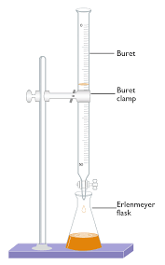

Quantitative Analysis

CHEM 2103

Summer 2020

**► Lecturer:** Dr. Nick Thomas

**► Office:** Room: 310‑I, Goodwyn Hall

**► Phone:** (334) 244‑3327

**► E‑mail:** nthomas@aum.edu

**► Class Days:**

**► Class Times:**

**► First Class Day:**

**► First Lab:**

**Online course for 2020**

The AUM administration has directed all summer courses, including lab courses, to be online for 2020. Therefore, all lectures and labs for this course will be delivered remotely via online resources. Course details will be provided soon.

**Course Description**

Quantitative Analysis (4). Pr., CHEM 1200 and CHEM 1201. Theory and application of volumetric and gravimetric analysis. Most industrial employment opportunities require CHEM 2103 and a knowledge of instrumental analysis.