Study guide for Chapter 21 – Nuclear Chemistry

if answers are not given here they can be easily found in the lecture notes)
1. Know the symbols and meanings (number of protons, neutrons in each) for an alpha and beta particle as well a proton and neutron. Need them to balance nuclear equations. For example, fill in the missing particle or isotope in the following nuclear reactions:
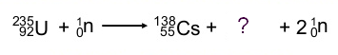
a.
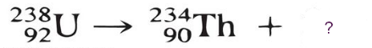
b.
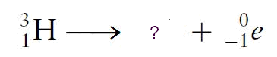
c.

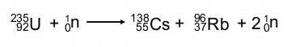
a.

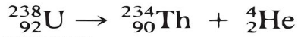
b.
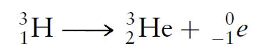
c.

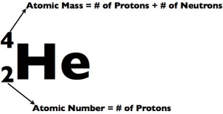
2. Know what the atomic/mass number symbol for an isotope means such as the one on the right.
And be able to calculate the numbers of protons, neutrons, electrons in an atom (this is revision from CHEM I)
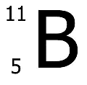
For example, how many protons, neutrons and electrons in this isotope of boron?

5 protons, 6 neutrons, 5 electrons
3. Know how to calculate nuclear binding energy and the energy released when an isotope undergoes a nuclear decay reaction (that is, when mass converts to energy). Method is very similar for both.
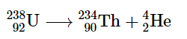
For example, U-238 decays according to the equation:

Calculate the energy released from the mass difference when 1 atom and 1 mole of U-238 undergoes radioactive decay. Given: c= 3 x10⁸ m/s; 1 amu = 1.66 x 10⁻²⁷ kg; And atomic masses for the isotopes: U-238 = 238.02891 amu, Th-234 =234.0436 amu , He-4 = 4.00260 amu
Mass difference is: 238.02891- (234.0236 + 4.00260) = 0.0271 amu
Convert to kg: 0.0271 x 1.66 x 10⁻²⁷ kg = 4.50 x 10⁻³⁰ kg
Use ∆E = ∆mc²
Energy = 4.50 x 10⁻³⁰ kg x (3 x10⁸ m/s)²
= 4.05 x 10⁻¹³ J for 1 atom of U-238
(remember, 1 J = 1 kg.m²/s²)
For 1 mole of U atoms, multiply the energy for 1 atom (above) by Avogadro’s number.

4. Know the fractions of isotope that would remain after 1 or more half-lives have elapsed. Eg after 1 half-life, 50% remains; after 2 half-lives, 25%, after 3, 12.5% etc (or 1/2, 1/4, 1/8, etc)
5. Know, in very general terms, how a nuclear power plant works and some of its components. (See lecture notes).
6. Know the difference between nuclear fission and nuclear fusion. (See lecture notes).
7. What’s significant about the Bi/Po point in the periodic table?
Po (after Bi) is the start of all the heavy radioactive elements.
8. Who are some important scientists in the early history of radioactivity? Rutherford, Becquerel, Curie, Röntgen
9. What are some sources of background radiation? (See lecture notes; radon is the largest source)
10. What are some common units of radiation? Rad, Rem, Becquerel, Curie, Gray, Sievert.

